**INDEX**

1. Abstract……………………………………………………………………………..2

2.Introduction……………………………………………………………………….....3

3. Literature Survey…………………………………………………………………….4

4. System Designing……………………………………………………………………5

5. Main Statement used………………………………………………………………...6

6. Source Code………………………………………………………………………….7

7. Flowchart……………………………………………………………………………..8

8. Algorithm……………………………………………………………………………..9

9. Output………………………………………………………………………………...10

10. Conclusion…………………………………………………………………………..11

11. Future Scope………………………………………………………………………...11

12. Reference……………………………………………………………………………12

**Abstract:**

This paper is scrutinizes the use of different terms and syntaxes in Computer Graphics, enabling viewer to get the complete concept of different aspects of Computer Graphics. To satisfy this we created a simple animation of a car moving from one point to another point which is created by various terms of graphics. A little use of looping is also used as a reference to the output, satisfying every need of a perfect graphics program.

**INTRODUCTION**

Computer graphics is a sub-field of computer science which studies methods for digitally synthesizing and manipulating visual content. Although the term often refers to the study of three-dimensional computer graphics, it also encompasses two-dimensional graphics and image processing**.** Computer graphics studies the manipulation of visual and geometric information using computational techniques. It focuses on the mathematical and computational foundations of image generation and processing rather than purely aesthetic issues. Computer graphics is often differentiated from the field of visualization, although the two fields have many similarities. Computer graphics deals with generating images with the aid of computers. Today, computer graphics is a core technology in digital photography, film, video games, cell phone and computer displays, and many specialized applications. n computer graphics, two or three-dimensional pictures can be created that are used for research. Many hardware devices algorithm has been developing for improving the speed of picture generation with the passes of time. It includes the creation storage of models and image of objects. These models for various fields like engineering, mathematical and so on. Today computer graphics is entirely different from the earlier one. It is not possible. It is an interactive user can control the structure of an object of various input devices



Fig.1. Computer Graphics

**Literature Survey:**

Graphics is defined as any sketch or a drawing or a special network that pictorially represents some meaningful information. Computer Graphics is used where a set of image needs to be manipulated or the creation of the image in the form of pixels and is drawn on the computer. Computer Graphics can be used in digital photography, film,entertainment, electronic gadgets and all other core technologies which are required. It is a vast subject and area in the field of computer science. Computer Graphics can be used in UI design, rendering, geometric object, animation and many more.In most area, computer graphics is an abbreviation of CG. There are several tools used for implementation of Computer Graphics. The basic is the <graphics.h> header file in Turbo-C, Unity for advanced and even OpenGL can be used for it’s Implementation. It was invented in 1960 by great researchers Verne Hudson and William Fetter from Boeing.

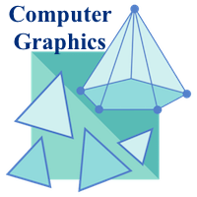

Fig.2.Computer Graphics II

**System Designing:**

This is a simple program which specifies the use of computer graphics in our daily life. It shows the animation of a car moving pixel by pixel until it reaches its destination. All aspects and terms of Computer Graphics were considered while creating this program.

First we included standard header files which is essential for every C and graphics program. We have to also include graphics header files which was mandatory to include in order to make program work. Then we created a function to make program a lit bit easier to understand and work.

In the function, we initalised graphics drivers and graphics mode. Then we started the program with a for loop in order to make a continuos loop of statements. We specifically chose for loop because it gave us more control than while or do-while loop, thanks to its condition statement accessibility. We set Parameter for For loop as: for (i=0;i<=420;i=i+10). This made the looping accessbile to the Output Screen making it viewable on screen. Then we set the color to white so that the outuput can be clearly seen on screen. We used a bunch of Line and Circle statements to design a car. Then with the help of increment operators we moved it by pixel everytime the loop is executed. Then we closed the graphics mode by closegraph() fuction.

After Completing the function we placed executed it in the main function of program, finishing the program. And it gives us the expected output we needed.

**Main Statements Used:**

#include<graphics.h>

#include<stdio.h>

initgraph(&gd,&gm.”C://TC3//BGI”)

for (i=0;i<=420;i=i+10)

line(0 + i, 300, 210 + i, 300)

circle(65 + i, 330, 15);

delay(100);

getch();

closegraph();

int main()

draw_moving_car();

return 0;

**Source Code**

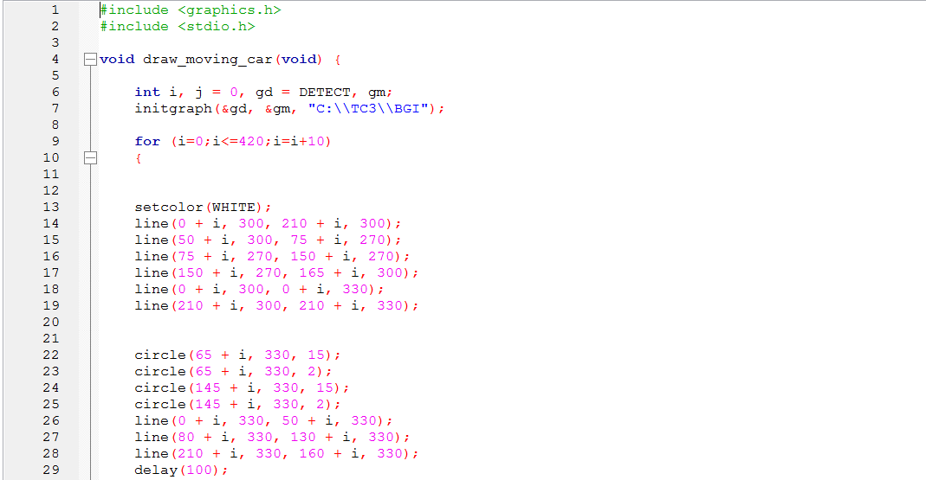

Fig.3.1. Code

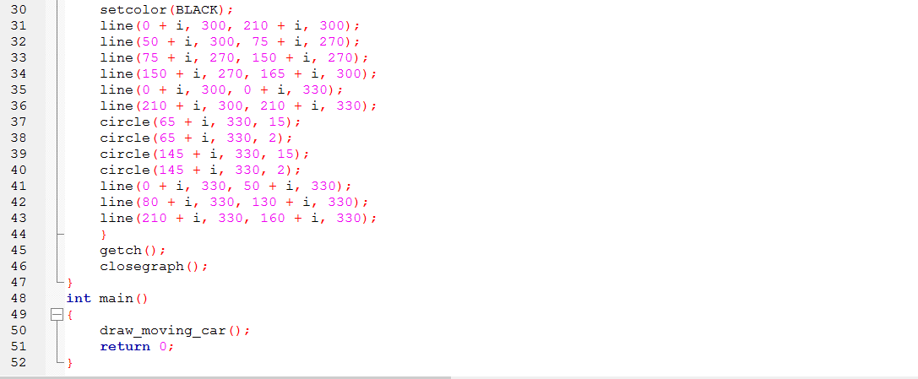Fig.3.2. Code II

**Flowchart**

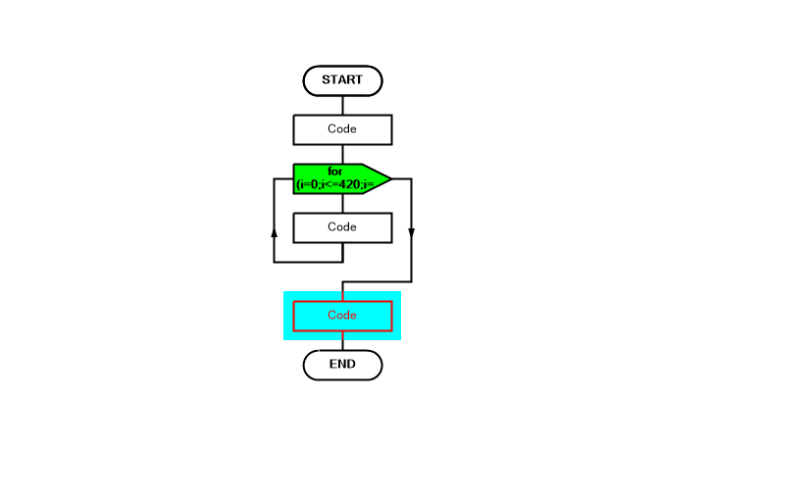

Fig.4.Flowchart

**Algorithm**

1. Start
2. Declare variable i,j
3. Intialise graphics driver and graphics mode.
4. Check for condition.
5. If condition is true then go to step 6, otherwise go to step 8.
6. Execute the code and increment i.
7. Go to step 4.
8. Stop.



Fig.5. Algorithm

**Output**

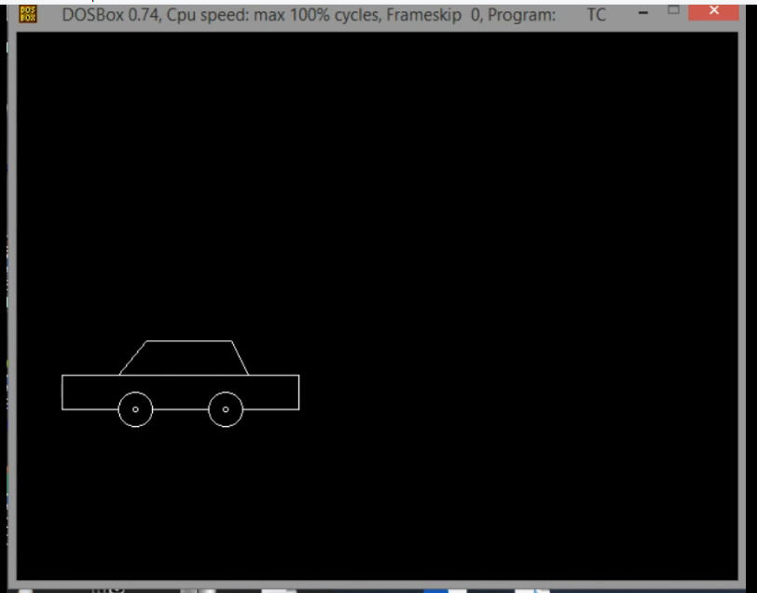

Fig.6.1. Output

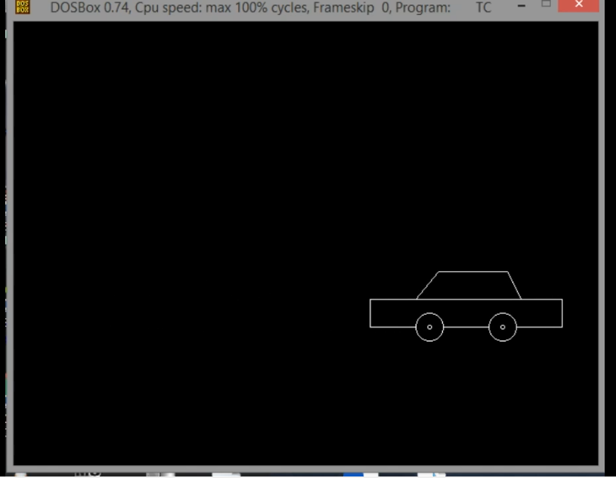

Fig.6.2. Output II

**Conclusion**

To display a picture of any size on a computer screen is a difficult process. Computer graphics are used to simplify this process. Various algorithms and techniques are used to generate graphics in computers. It involves computations, creation, and manipulation of data.

In other words, we can say that computer graphics is a rendering tool for the generation and manipulation of images. Interactive computer graphics work using the concept of two-way communication between computer users. The computer will receive signals from the input device, and the picture is modified accordingly.

Picture will be changed quickly when we apply command.

**Future Scope**

This project will help users to understand about grpahics and understand them. Computer Graphics mean creating images with use of computer. It is a main aspect of Computer Science. So in order to learn various concepts and aspects of Graphics we have created this project using C and C++. This project contains a lot of work especially the creator. Using various statement makes the work messy but fruitful.

Animation is main aspect of graphics. Real Life interaction make things better understandable. It make’s people learn faster as compared to plain text. Computer Graphics focuses on it complexity and logic more easy than it shall look.

This project is prototype right now, but it will be more developed in future. As we learn more concepts about it the more developed it will be as time passes. All sort of information was adapted from learning and practicing.

Users Discretion is Advised.

**References**

1. "geometryprocessing.org". geometryprocessing.org. Retrieved 2014-05-01.
2. Archived March 14, 2007, at the Wayback Machine
3. "High Performance Graphics". highperformancegraphics.org.
4. "Best Practices Memo". Cra.org. Archived from the original on 2014-05-02. Retrieved 2014-05-01.
5. "Choosing a venue: conference or journal?". People.csail.mit.edu. Retrieved 2014-05-01.
6. "Graphics/vision publications acceptance rates statistics". vrlab.epfl.ch. Retrieved 2014-05-01.
7. An extensive history of computer graphics can be found at this page Archived April 5, 2007, at the Wayback Machine.
8. "Point Based Graphics 2007 - PBG07". Graphics.ethz.ch. Retrieved 2014-05-01.
9. "Ron Fedkiw". graphics.stanford.edu. Retrieved 2014-05-01.
10. Archived February 14, 2007, at the Wayback Machine
11. CS 598: Digital Geometry Processing (Fall 2004) Archived 2004-10-25 at Archive.today
12. "Digital Geometry Processing". cs.ubc.ca. Retrieved 2014-05-01.
13. "Discrete Differential Geometry". ddg.cs.columbia.edu. Retrieved 2014-05-01.